How to Access Your Patients Approved for Allē Payment Plans
Follow 3 steps to download a list of patients with approved, active Payment Plans balances in their Allē Wallet.

Step | Reference
1. View a list of your patients who are approved for Allē Payment Plans in Insights.  Business Admins, Location Managers, and Staff Members can find Insights from the left-hand navigation menu. | 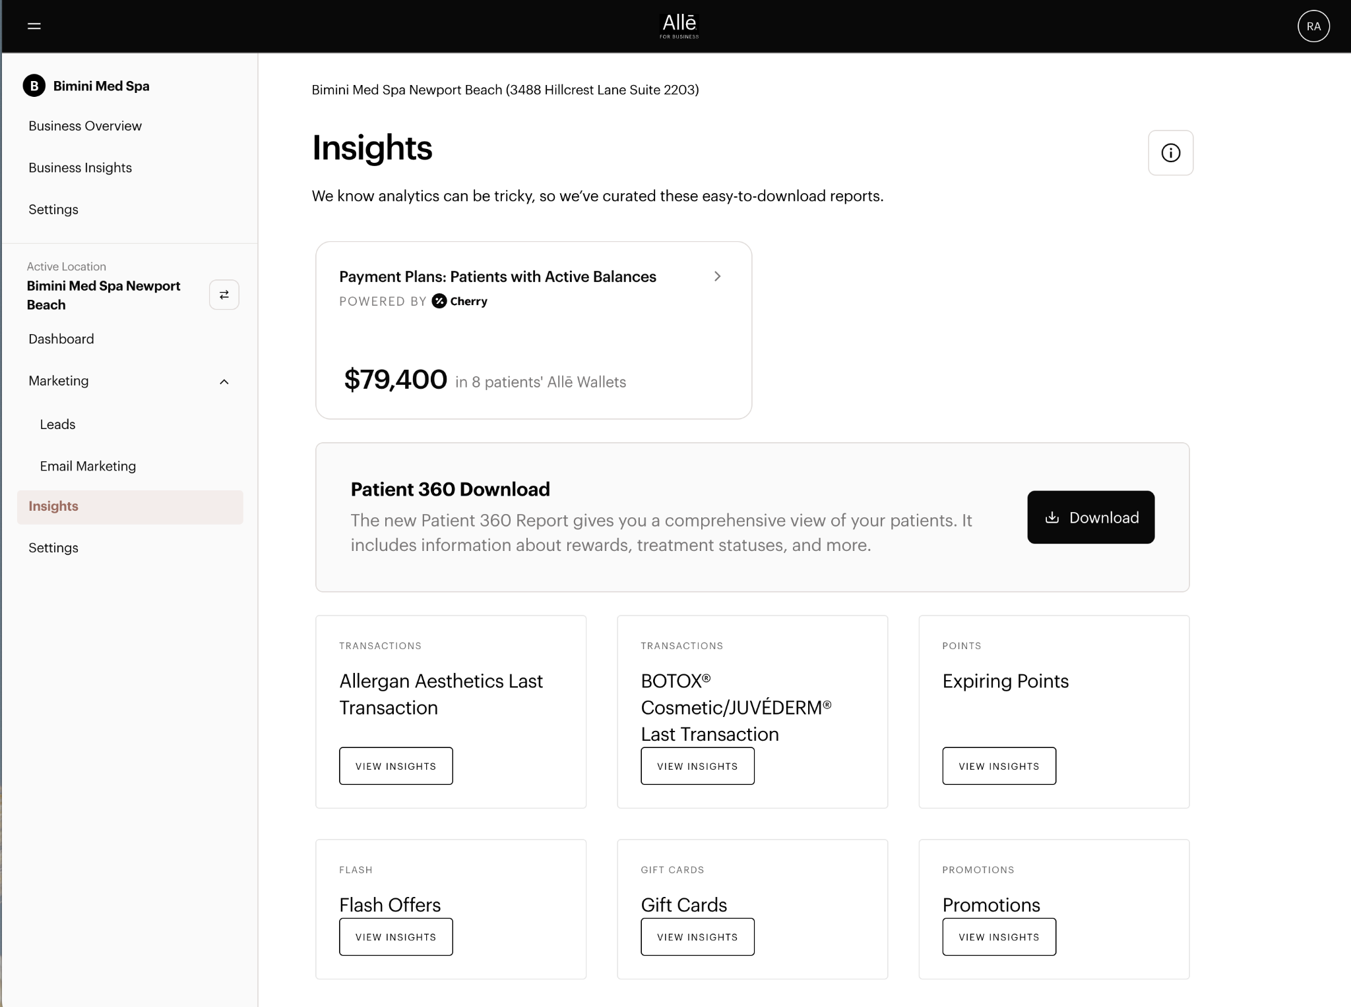
2. Selecting Payment Plans: Patients with Active Balances will open a dedicated report that lists patients who have visited your practice in the last 2 years who have an active, approved Payment Plans balance remaining. | 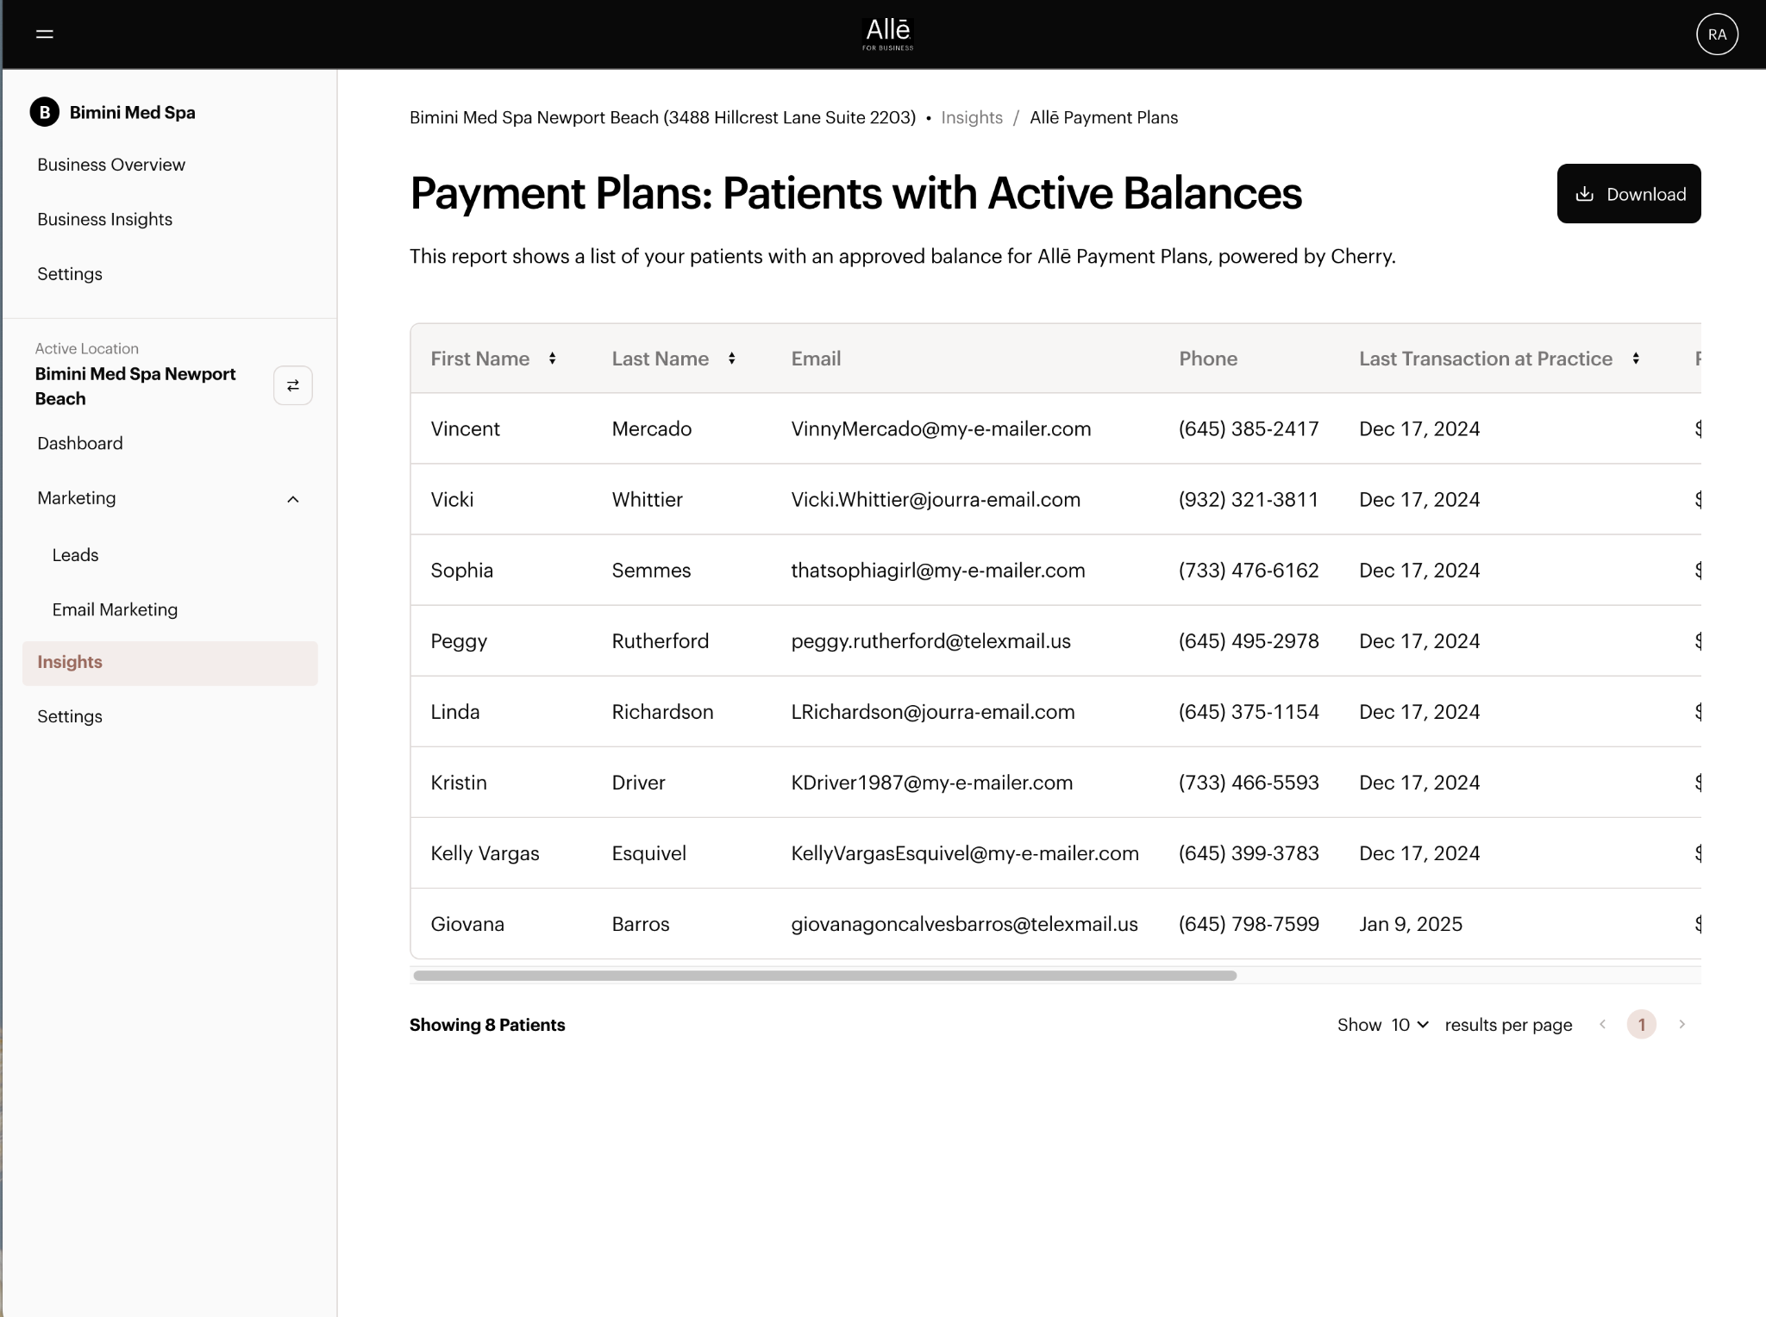
3. Click the Download button in the upper-right corner to export the information into an Excel file (.csv).  Open this file and find your approved patients’ email addresses. Then, upload the list into your Email Marketing platform as the recipient of the Payment Plans Balance Reminder Email in BrandBox. | 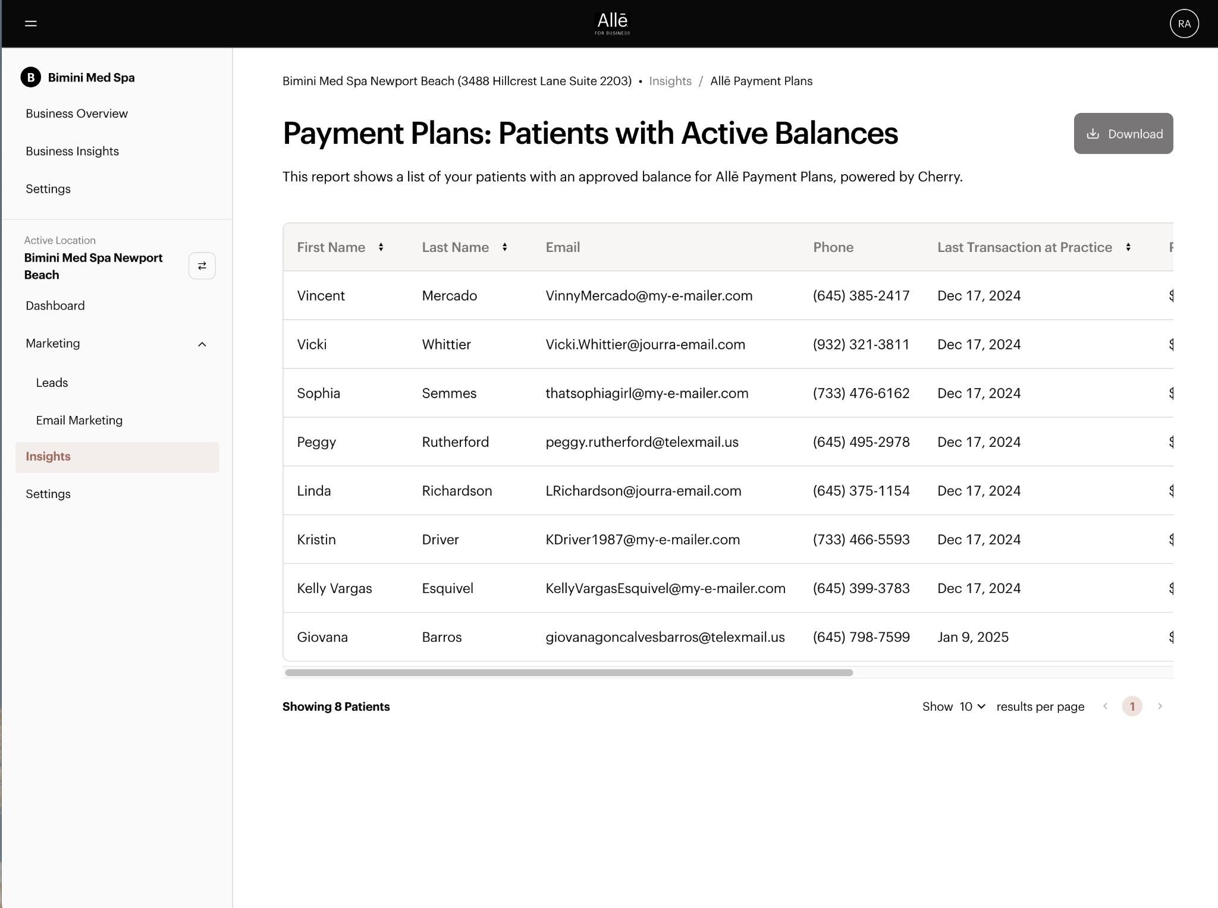

© 2025 AbbVie. All rights reserved. Allē and its design are service marks of Allergan, Inc., an AbbVie company. MLRC-77 02/25

