Channel: Instagram/Facebook
Title: What’s Your Squish Level?

Story Poll:

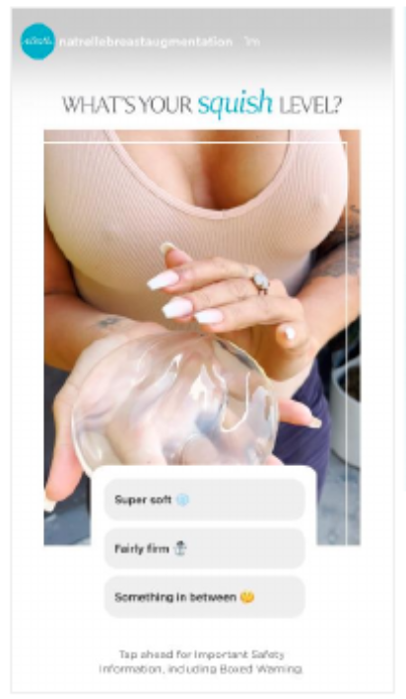

Story Poll Caption

What’s Your Squish Level?
– Super Soft❄️
– Fairly Firm☃️
– Something In Between��

Important Safety Information
For Instagram & Facebook - Please add ISI frames as last image

