Channel: Instagram/Facebook Stories
Title: What do you want to learn?

Story Poll:

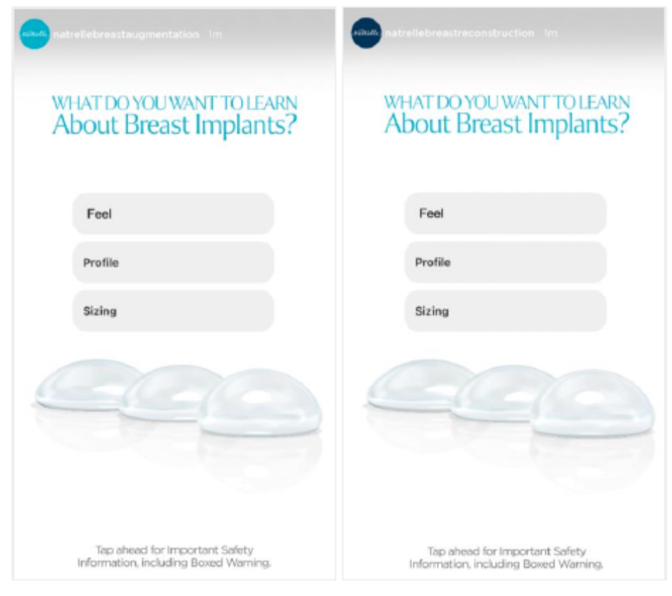

Story Poll Caption

- Feel
- Profile
- Sizing

Important Safety Information
For Instagram & Facebook - Please add ISI frames as last images

