Channel: Instagram/Facebook
Title: Visualize Your New Look

Story Video Post

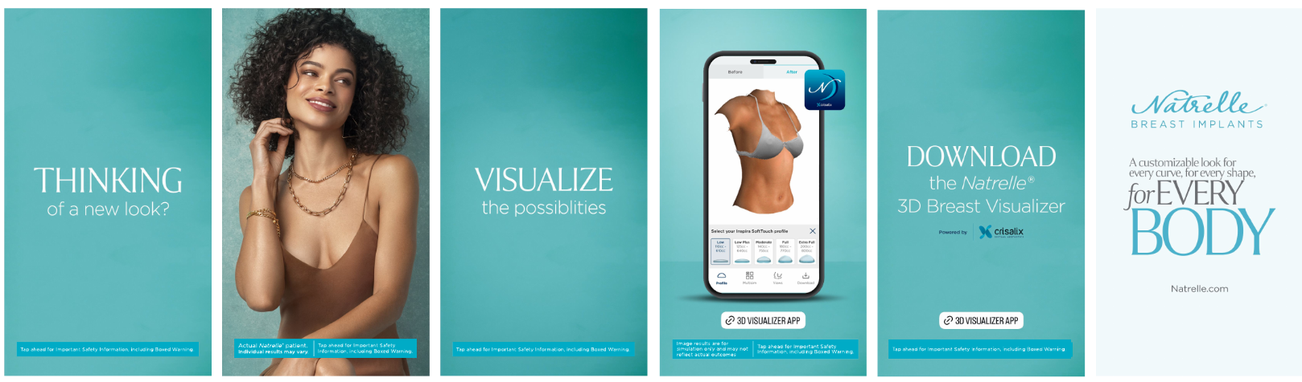

Important Safety Information

ISI included in video

