Channel: Instagram/Facebook
Title: Geek Out On Gummy Cohesivity

Multi-Image Post:

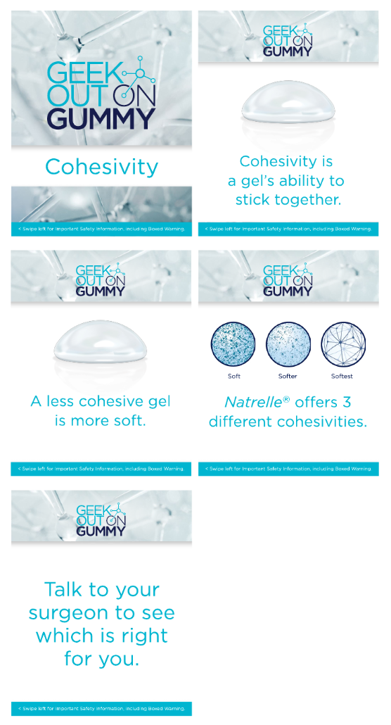

Post-Copy Caption

Inside every silicone breast implant is a gel. But not all gels are the same. That's where a scientific term known as cohesivity comes in. Cohesivity is how well the gel sticks together. Natrelle® is
the only one to offer 3 choices of gel cohesivity.

Feel for yourself. Contact our office for more information or schedule a consultation and feel the difference in gel cohesivities and which best meet your aesthetic goals.

#natrelle #natrelleimplants #gogummy #breastimplants #siliconeimplants #breastaugmentation
#geekoutongummy #breastimplantgels #smoothimplants #softimplants #breastimplantscience

Important Safety Information
For Instagram - Please add ISI frames as last image
For Facebook-Please add ISI copy to post copy.

