Channel: Instagram/Facebook
Title: The Most Customization Options

REEL

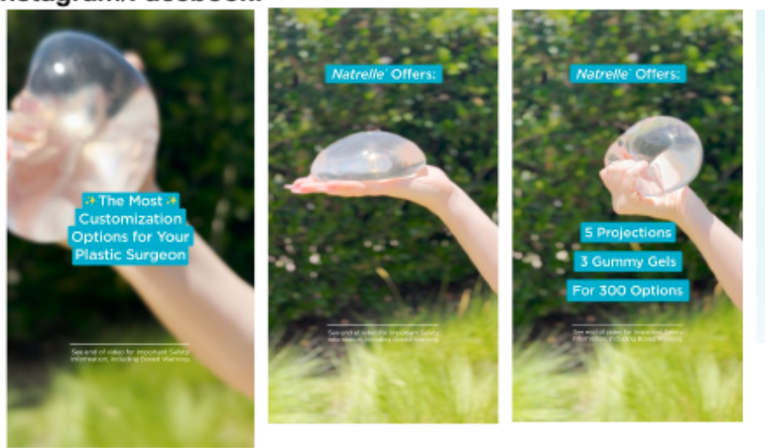

Post-Copy Caption

Natrelle® is the only breast implant brand that offers 5 projection options and 3 gummy gel levels.

Natrelle® has the largest collection of smooth implants available (300 implants, to be exact), so you and your surgeon can create a look that feels like you.

Projection means how far the implant projects forward from your body, and gummy gel is the level of
softness of the implant.

Have you been considering breast augmentation and are ready to book your first consultation?
Contact our office for more information.

#gogummy #askaplasticsurgeon #breastaugmentation #augmentation #gummyimplants #plasticsurgery #gelimplants #breastimplants #natrellegummy #natrellecollection #largestimplantcollection #breastimplantoptions #natrelleimplants #natrelleinspira #natrelle

Important Safety Information
For Facebook-Please add ISI copy to post copy.

