Channel: Instagram/Facebook
Title: Bikini Ready Poll Post

Story Poll - STORYBOARD:

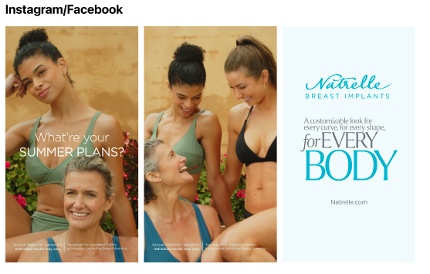

POLL-Copy

Travel
Beach/Pool
Sun/Nature
Family time

Important Safety Information

For Instagram: Add ISI to the last frame.
For Facebook: Add ISI to the last frame.

