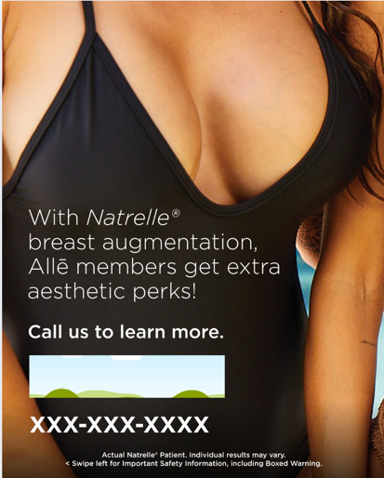

Natrelle® Perks Customizable Canva Template

How To: Use these directions to download the editable Canva social media template.
Step 1: Click this link to view the template:
https://www.canva.com/design/DAGr9r-hx5M/KtjnW9QB-BV06hJncXN_nw/view?utm_content=DAGr9r-hx5M&utm_campaign=designshare&utm_medium=link&utm_source=publishsharelink&mode=preview
Step 2: If you have Canva, you can directly edit the file and move to step 3. If you do not, make Canva account with your email. It is free and takes 1 minute.
Step 3: Once in the platform, you can update the social template with your information by directly clicking the icon that looks like a “photo frame” 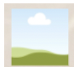and your phone number (XXX) XXX-XXXX In the photo frame icon, you can drag and drop your practice’s logo/your headshot (.png/.jpeg) from your computer.
Step 4: Add your practice’s phone number by clicking & deleting the (XXX) XXX-XXXX on the template
Note: Everything on the social template besides your logo/headshot + phone number are locked, so you cannot alter anything else on this image.
Step 5: Done! Click the “Download” icon 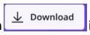in the upper right corner. Click on “file type” and scroll down and choose “PNG” to download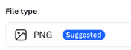 this full asset. Press “Download.”
Step 6: Your file is now downloaded to your computer & most likely in your “downloads” folder. Send the image(s) to yourself via Airdrop/email/or the method of your choice. Now, share it on social — upload it to IG/FB!
Approved Suggested Caption Copy:

IG/FACEBOOK POST COPY

Natrelle® breast augmentation means you can be eligible
to receive perks. Allē members who choose Natrelle® for
their breast augmentation can receive 500 Allē points
and a complimentary aesthetic treatment. Natrelle® is
packed with perks.

Call to learn more.

