Channel: Instagram/Facebook
Title: Product (1, 10, 100)

REEL:

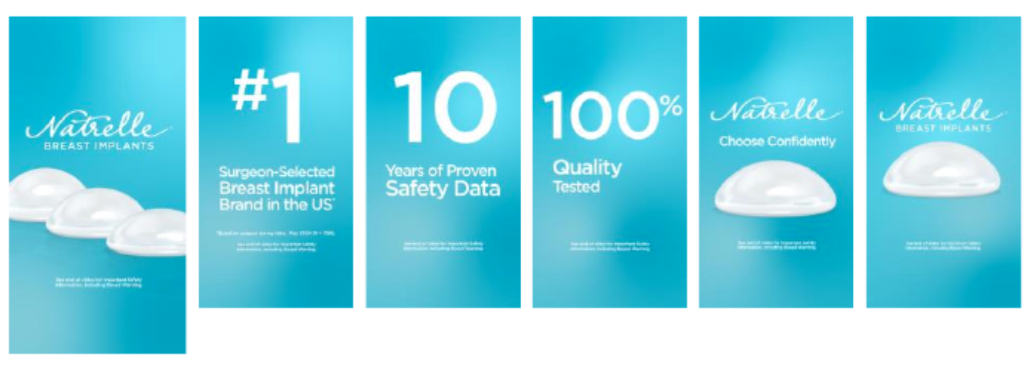

Post-Copy Caption

With Natrelle® Breast Implants, patient safety is our top priority.

Natrelle® is committed to delivering excellence and innovation when it comes to breast
implants. Not only does Natrelle® have reliable safety data, with the many customization options, we can give our patients the look they want!

Contact our office for more information or schedule a consultation.

#gogummy #askaplasticsurgeon #breastaugmentation #augmentation #gummyimplants #plasticsurgery #gelimplants #breastimplants #surgeonselected #implantsafetydata
#breastimplantwarranty #natrellesafety #natrelleimplants #natrelleinspira #natrelle

Important Safety Information
For Facebook-Please add ISI copy to post copy.

