Channel: Instagram/Facebook
Title: Gel Breast Implants Made To Feel Like You

REEL

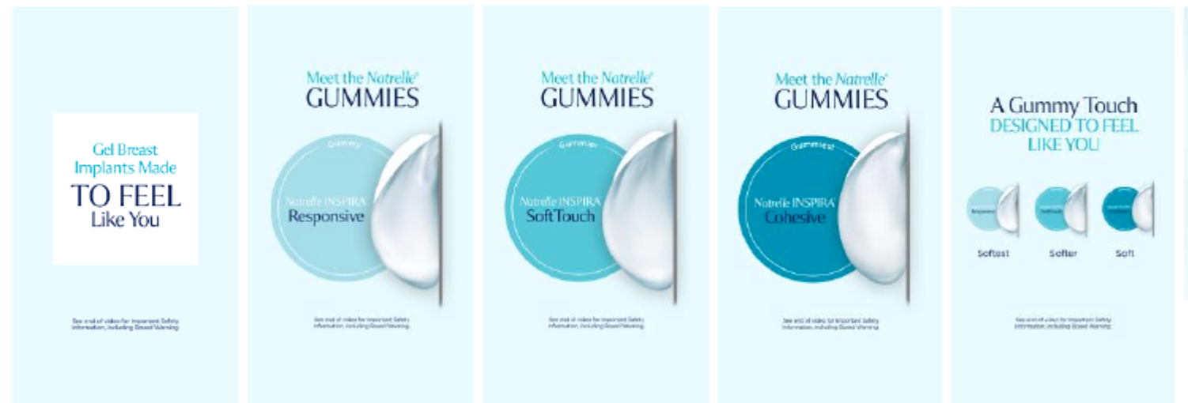

Post-Copy Caption

We love the gummy.

Whatever feel you want to achieve, Natrelle® is the only implant brand to offer 3 levels of gummy, ranging from soft, softer, to softest. "Gummy" refers to the cohesivity, or consistency, of the gel in breast implants. The more cohesive the implant, the more it holds its shape when held in your hand.*

To learn more about the gummy of Natrelle®, contact our office for more information or schedule a consultation.

*Significance inside the body has not been established.

#gogummy #askaplasticsurgeon #breastaugmentation #augmentation #gummyimplants #plasticsurgery #gelimplants #breastimplants #gummynatrelle #gummybreastimplant #cohesivebreastimplant #natrelleimplants #natrelleinspira #natrelle

Important Safety Information
For Facebook-Please add ISI copy to post copy.

