Channel: Instagram/Facebook
Title: Geek Out On Gummy Shell Design

REEL:

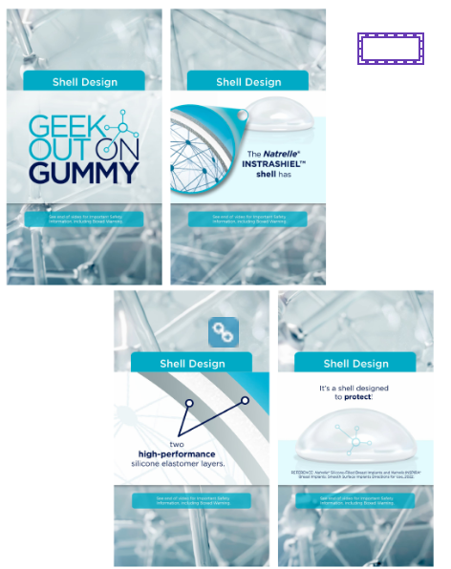

Post-Copy Caption

Let's Geek out on Gummy Shell Design. An important part of a breast implant is its outside surface, known as the shell. Natrelle® smooth breast implants have INTRASHIEL™ barrier shell technology.

The barrier layer minimizes gel diffusion through the shell (<1% gel diffusion rate)*. This means the silicone gel stays where it belongs, inside the implant. When Natrelle gel implants are cut ex vivo, the gel stays in place.†

Natrelle® is the only one to have this INTRASHIELD technology. Contact our office for more information or schedule a consultation.

*Low molecular weight silicones and platinum.

†In vivo significance has not been established.

#natrelle #natrelleimplants #gogummy #breastimplants #siliconeimplants #breastreconstruction #geekoutongummy #breastimplantgels #implantshell #breastimplantconstruction #breastimplantscience

Important Safety Information - For Facebook-Please add ISI copy to post copy.

