Channel: Instagram/Facebook
Title: Decision tree post about “Are you ready to book a consult?

Multi-Image Post:

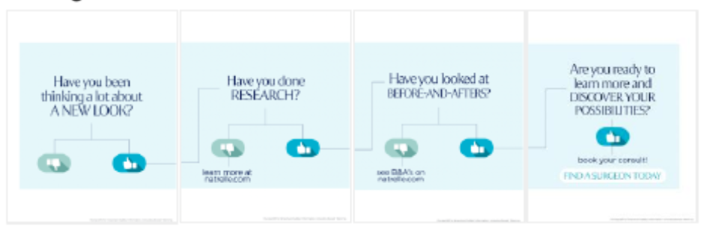

Post-Copy Caption

Are you ready for a breast augmentation consultation? Let this decision tree help you!

When on a breast augmentation journey, everyone goes through each of these phases. Follow
the lines to see where you’re at.

Did you make it to the end? Contact our office for more information or schedule a consultation.

#gogummy #askaplasticsurgeon #breastaugmentation #augmentation
#gummyimplants #plasticsurgery #gelimplants #breastimplants #consultation

Important Safety Information

For Instagram - Please add ISI frames as last image
For Facebook-Please add ISI copy to post copy.

