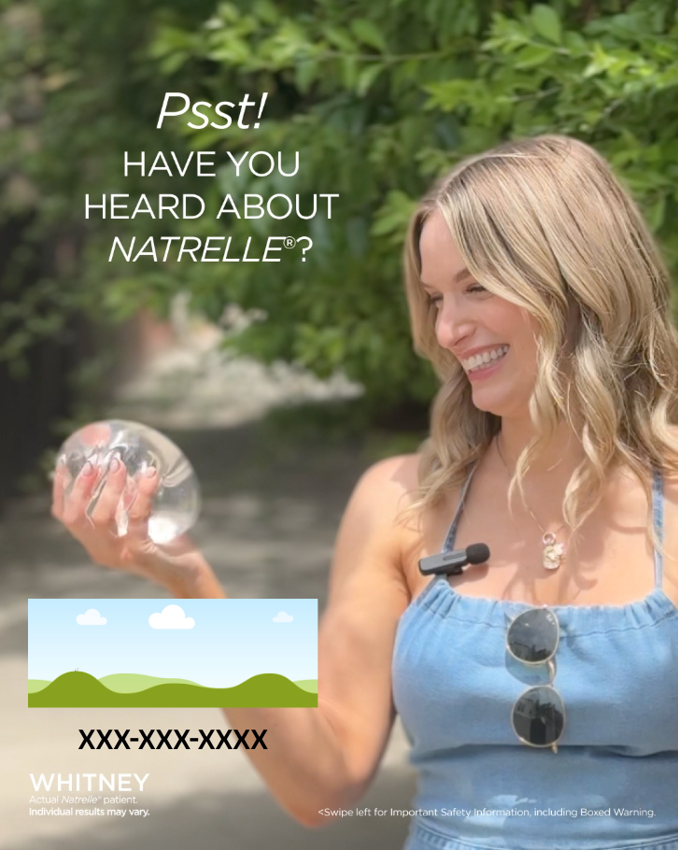

Have you heard of Natrelle® Customizable Canva Template

How To: Use these directions to download the editable Canva social media template.
Step 1: Click this link to view the template:
Step 2: If you have Canva, you can directly edit the file and move to step 3. If you do not, make Canva account with your email. It is free and takes 1 minute.
https://www.canva.com/design/DAGzTrlpysA/87SGNISu2VbSKp11ZqlyLA/view?utm_content=DAGzTrlpysA&utm_campaign=designshare&utm_medium=link&utm_source=publishsharelink&mode=preview
Step 3: Once in the platform, you can update the social template with your information by directly clicking the icon that looks like a “photo frame” 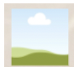and your phone number (XXX) XXX-XXXX In the photo frame icon, you can drag and drop your practice’s logo/your headshot (.png/.jpeg) from your computer.
Step 4: Add your practice’s phone number by clicking & deleting the (XXX) XXX-XXXX on the template
Note: Everything on the social template besides your logo/headshot + phone number are locked, so you cannot alter anything else on this image.
Step 5: Done! Click the “Download” icon 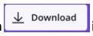in the upper right corner. Click on “file type” and scroll down and choose “PNG” to download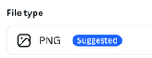 this full asset. Press “Download.”
Step 6: Your file is now downloaded to your computer & most likely in your “downloads” folder. Send the image(s) to yourself via Airdrop/email/or the method of your choice. Now, share it on social — upload it to IG/FB!
Approved Suggested Caption Copy:

IG/FACEBOOK POST COPY

We are here to guide you on your breast augmentation journey! When you schedule a consultation with us, we’ll discuss your aesthetic goals and desires, and you’ll learn about volume and projection as we discuss the right size and fit for you!

Call us today and schedule!

NAT162011

