Channel: Instagram/Facebook
Title: Natrelle Perks Social Post with Botox and Juvederm
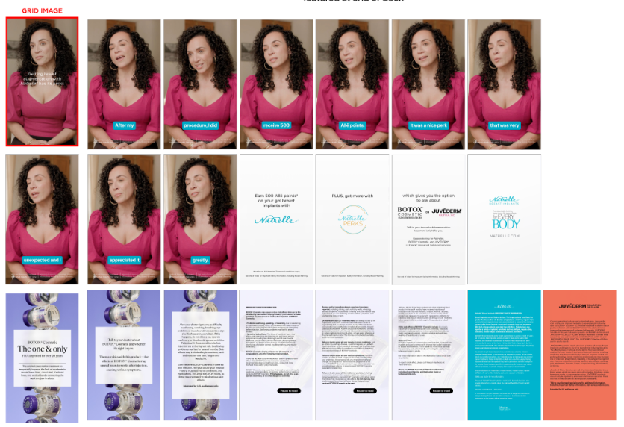

Post-Copy Caption

See @botoxcosmeticPI for Boxed Warning and Medication Guide.

Want more than just results? With Natrelle® breast augmentation, you’ll love your look and
get rewarded. Earn 500 Allē points, and ask about BOTOX® Cosmetic or JUVÉDERM® Ultra XC for lips with Natrelle PERKS®.

Learn more about Natrelle PERKS®. Schedule your consultation today!

Must be an Allē Member. Terms and conditions apply. Talk to your doctor about which treatment
may be right for you. Keep watching for Natrelle® Important Safety Information, including Boxed
Warning.

Talk to your doctor about BOTOX® Cosmetic and whether it’s right for you. There are risks with this product—the effects of BOTOX® Cosmetic may spread hours to weeks after injection causing serious symptoms. Alert your doctor right away as difficulty swallowing, speaking, breathing, eye problems, or muscle weakness can be a sign of a life-threatening condition. If this happens, do not drive a car, operate machinery, or do other dangerous activities. Patients with these conditions before injection are at the highest risk. Swallowing problems may last for several months. Side
effects may include allergic reactions, neck and injection-site pain, fatigue, and headache. Don’t receive BOTOX® Cosmetic if there’s a skin infection. Tell your doctor your medical history, muscle or nerve conditions, and medications, including botulinum toxins, as these may increase the risk of serious side effects.

Intended for US audiences only.

#natrellePERKS #TruetoNatrelle #NatrelleTells #Askaplasticsurgeon #breastaug #natrelle#alle #allepoints #allemembers #AlleApp #AlleOffer#breastaugmentation #gummybearimplants #natrelleimplants #juvedermfiller #AllerganAesthetics

US-PRT-SM-00801

Important Safety Information
For Instagram: ISI already added into reel
For Facebook- ISI already added into reel

For Facebook ISI - Copy is Below - Please add after Caption

Natrelle® Breast Implants IMPORTANT SAFETY INFORMATION AND APPROVED USES
Breast implants are not considered lifetime devices. The longer people have them, the greater the chances are that they will develop complications, some of which will require more surgery.
Breast implants have been associated with the development of a cancer of the immune system called breast implant–associated anaplastic large cell lymphoma (BIA-ALCL). This cancer occurs more commonly in patients with textured breast implants than smooth implants, although rates are not well defined. Some patients have died from BIA-ALCL.
Patients receiving breast implants have reported a variety of systemic symptoms, such as joint pain, muscle aches, confusion, chronic fatigue, autoimmune diseases, and others. Individual patient risk for developing these symptoms has not been well established. Some patients report complete resolution of symptoms when the implants are removed without replacement.
Who can get breast implants?
Natrelle® Breast Implants are approved for the following:
- Breast augmentation for women at least 22 years old for silicone-filled implants and for women at least 18 years old for saline-filled implants. Breast augmentation includes primary breast augmentation to increase the breast size and revision surgery to correct or improve the result of a primary breast augmentation
- Breast reconstruction. This includes primary breast reconstruction to replace breast tissue that has been removed due to cancer or trauma or that has failed to develop properly due to a severe breast abnormality. This also includes revision surgery to correct or improve the result of a primary breast reconstruction
Who should NOT get breast implants?
Breast implant surgery should NOT be performed in:
- Women with active infection anywhere in their body
- Women with existing cancer or precancer of their breast who have not received adequate treatment for those conditions
- Women who are currently pregnant or nursing

What should I tell my doctor?
Tell your doctor if you have any of the following conditions, as the risks of breast implant surgery may be higher:
- Autoimmune diseases (eg, lupus and scleroderma)
- A weakened immune system (eg, taking medications to decrease the body’s immune response)
- Planned chemotherapy or radiation therapy following breast implant placement
- Conditions or medications that interfere with wound healing and blood clotting
- Reduced blood supply to breast tissue
- Clinical diagnosis of depression or other mental health disorders, including body dysmorphic disorder and eating disorders
- Those with a diagnosis of depression or other mental health disorders should wait for resolution or stabilization of these conditions prior to undergoing breast implantation surgery
What else should I consider?
- There is a Boxed Warning for breast implants. Please see bold text at beginning
- Many changes to your breasts following implantation are irreversible. If you later choose to have your implants removed and not replaced, you may experience dimpling, puckering, wrinkling, or other cosmetic changes, which may be permanent
- Breast implantation is likely not a one-time surgery. The longer implants are in place, the greater the potential risk for complications. You will likely need additional surgeries on your breasts due to complications or unacceptable cosmetic results. Thus, you should also consider the complication rates for later (revision) surgery since you may experience these risks in the future
- Cancer treatments and surgery will affect the outcome and timing of breast reconstruction
- Breast implants may affect your ability to breastfeed, either by reducing or eliminating milk production
- Rupture of a silicone-filled breast implant is most often silent. Even if you have no symptoms, you should have your first ultrasound or MRI at 5 to 6 years after your initial implant surgery and then every 2 to 3 years thereafter regardless of whether your implants are for augmentation or reconstruction. If you have symptoms of or uncertain ultrasound results for breast implant rupture, an MRI is recommended. Additional imaging may be required depending on your medical history and status. The health consequences of a ruptured silicone gel-filled breast implant have not been fully established
- Routine screening mammography for breast cancer will be more difficult, and implants may rupture during the procedure. Perform self-examination every month for cancer screening and ask your surgeon to help you distinguish the implant from your breast tissue. Lumps, persistent pain, swelling, hardening, or changes in implant shape should be reported to your surgeon and possibly evaluated with imaging

What are key complications with breast implants?
Key complications include reoperation, implant removal with or without replacement, implant rupture with silicone-filled implants, implant deflation with saline-filled implants, and capsular contracture (severe scar tissue around the implant). Other complications include breast pain, swelling, asymmetry, wrinkling/rippling, implant malposition nipple complications, hypertrophic scarring, and implant palpability/visibility.

Talk to your doctor about other complications.

For more information, see the patient brochures at www.allergan.com/products.

To report a problem with Natrelle® Breast Implants, please call Allergan® at 1-800-624-4261.
The sale and distribution of Natrelle® Breast Implants is restricted to licensed physicians who provide information to patients about the risks and benefits of breast implant surgery.

