Channel: Instagram/Facebook
Title: Geek Out On Gummy -Tissue Expander

Story Video:

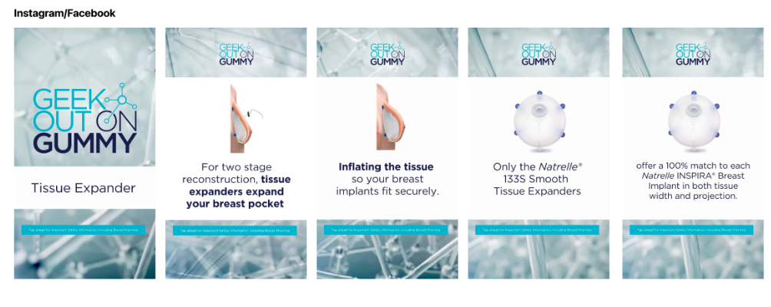

Important Safety Information

ISI included in video

