Channel: Instagram/Facebook
Title: Geek Out On Gummy - Profiles

STORY VIDEO:

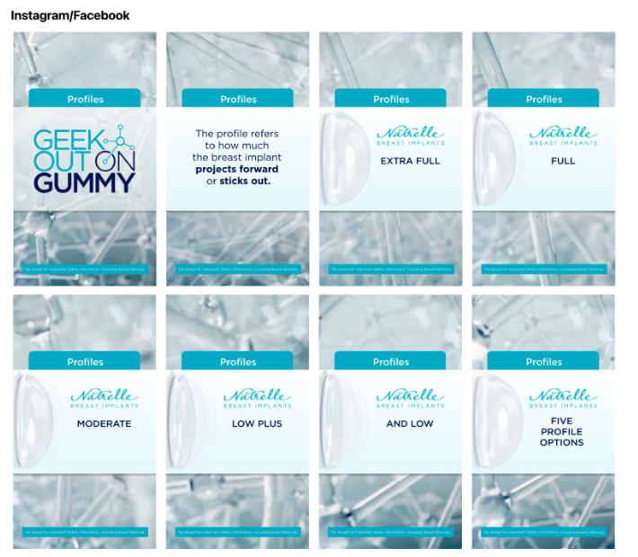

Important Safety Information

ISI included in video

