Channel: Instagram/Facebook
Title: Finance Your Natrelle INSPIRA Breast Augmentation

Static Post: IG_24-08_April_BrandBox_Static_Post_2 & FB_24-08_April_BrandBox_Static_Post_2

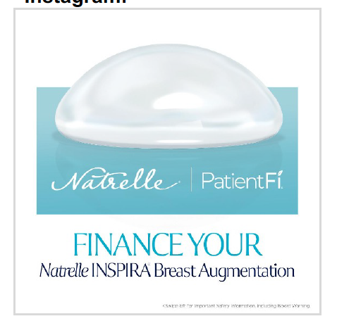

Post-Copy Caption

You can get a customized financing plan for your new look with
PatientFi®, created for Natrelle INSPIRA® breast augmentation
patients. Get a payment plan that fits your budget with 0% interest*
plans available, flexible payment terms, and no hard credit checks. It's
financing, with you at the center.

Contact our office to learn more and apply for PatientFi® today.

*No interest if paid in full during the promotional period.

Important terms and conditions: All financing is subject to credit approval. Depending on
creditworthiness and choice of financing option, APRs range between 6.99% and 29.99%.
Scheduled payments are based on the full contract term length. Not every provider offers all product
term lengths and promotions. Please inquire which term lengths and promotions are available.
Allergan Aesthetics is not a financing company and is not responsible for and does not support the
financing referenced herein. All financing and support are provided by PatientFi. Patients and
healthcare providers should contact PatientFi with any questions. Patients should apply directly to
PatientFi for financing.

Important Safety Information
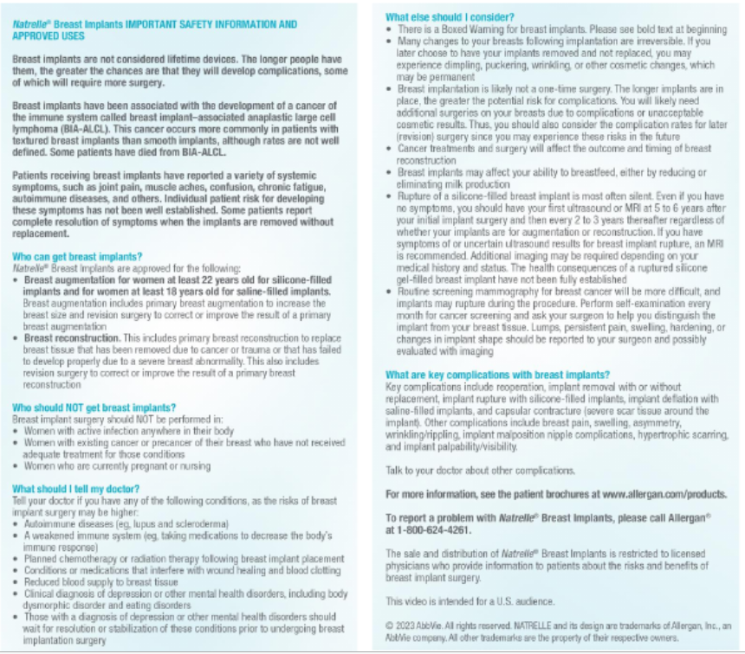

Facebook ISI

Natrelle® Breast Implants IMPORTANT SAFETY INFORMATION AND APPROVED USES
Breast implants are not considered lifetime devices. The longer people have them, the greater the chances are that they will develop complications, some of which will require more surgery.
Breast implants have been associated with the development of a cancer of the immune system called breast implant–associated anaplastic large cell lymphoma (BIA-ALCL). This cancer occurs more commonly in patients with textured breast implants than smooth implants, although rates are not well defined. Some patients have died from BIA-ALCL.
Patients receiving breast implants have reported a variety of systemic symptoms, such as joint pain, muscle aches, confusion, chronic fatigue, autoimmune diseases, and others. Individual patient risk for developing these symptoms has not been well established. Some patients report complete resolution of symptoms when the implants are removed without replacement.
Who can get breast implants?
Natrelle® Breast Implants are approved for the following:
- Breast augmentation for women at least 22 years old for silicone-filled implants and for women at least 18 years old for saline-filled implants. Breast augmentation includes primary breast augmentation to increase the breast size and revision surgery to correct or improve the result of a primary breast augmentation
- Breast reconstruction. This includes primary breast reconstruction to replace breast tissue that has been removed due to cancer or trauma or that has failed to develop properly due to a severe breast abnormality. This also includes revision surgery to correct or improve the result of a primary breast reconstruction
Who should NOT get breast implants?
Breast implant surgery should NOT be performed in:
- Women with active infection anywhere in their body
- Women with existing cancer or precancer of their breast who have not received adequate treatment for those conditions
- Women who are currently pregnant or nursing

What should I tell my doctor?
Tell your doctor if you have any of the following conditions, as the risks of breast implant surgery may be higher:
- Autoimmune diseases (eg, lupus and scleroderma)
- A weakened immune system (eg, taking medications to decrease the body’s immune response)
- Planned chemotherapy or radiation therapy following breast implant placement
- Conditions or medications that interfere with wound healing and blood clotting
- Reduced blood supply to breast tissue
- Clinical diagnosis of depression or other mental health disorders, including body dysmorphic disorder and eating disorders
- Those with a diagnosis of depression or other mental health disorders should wait for resolution or stabilization of these conditions prior to undergoing breast implantation surgery
What else should I consider?
- There is a Boxed Warning for breast implants. Please see bold text at beginning
- Many changes to your breasts following implantation are irreversible. If you later choose to have your implants removed and not replaced, you may experience dimpling, puckering, wrinkling, or other cosmetic changes, which may be permanent
- Breast implantation is likely not a one-time surgery. The longer implants are in place, the greater the potential risk for complications. You will likely need additional surgeries on your breasts due to complications or unacceptable cosmetic results. Thus, you should also consider the complication rates for later (revision) surgery since you may experience these risks in the future
- Cancer treatments and surgery will affect the outcome and timing of breast reconstruction
- Breast implants may affect your ability to breastfeed, either by reducing or eliminating milk production
- Rupture of a silicone-filled breast implant is most often silent. Even if you have no symptoms, you should have your first ultrasound or MRI at 5 to 6 years after your initial implant surgery and then every 2 to 3 years thereafter regardless of whether your implants are for augmentation or reconstruction. If you have symptoms of or uncertain ultrasound results for breast implant rupture, an MRI is recommended. Additional imaging may be required depending on your medical history and status. The health consequences of a ruptured silicone gel-filled breast implant have not been fully established
- Routine screening mammography for breast cancer will be more difficult, and implants may rupture during the procedure. Perform self-examination every month for cancer screening and ask your surgeon to help you distinguish the implant from your breast tissue. Lumps, persistent pain, swelling, hardening, or changes in implant shape should be reported to your surgeon and possibly evaluated with imaging

What are key complications with breast implants?
Key complications include reoperation, implant removal with or without replacement, implant rupture with silicone-filled implants, implant deflation with saline-filled implants, and capsular contracture (severe scar tissue around the implant). Other complications include breast pain, swelling, asymmetry, wrinkling/rippling, implant malposition nipple complications, hypertrophic scarring, and implant palpability/visibility.

Talk to your doctor about other complications.

For more information, see the patient brochures at www.allergan.com/products.

To report a problem with Natrelle® Breast Implants, please call Allergan® at 1-800-624-4261.

The sale and distribution of Natrelle® Breast Implants is restricted to licensed physicians who provide information to patients about the risks and benefits of breast implant surgery.

