Channel: Instagram/Facebook
Title: Smooth Tissue Expander

REEL

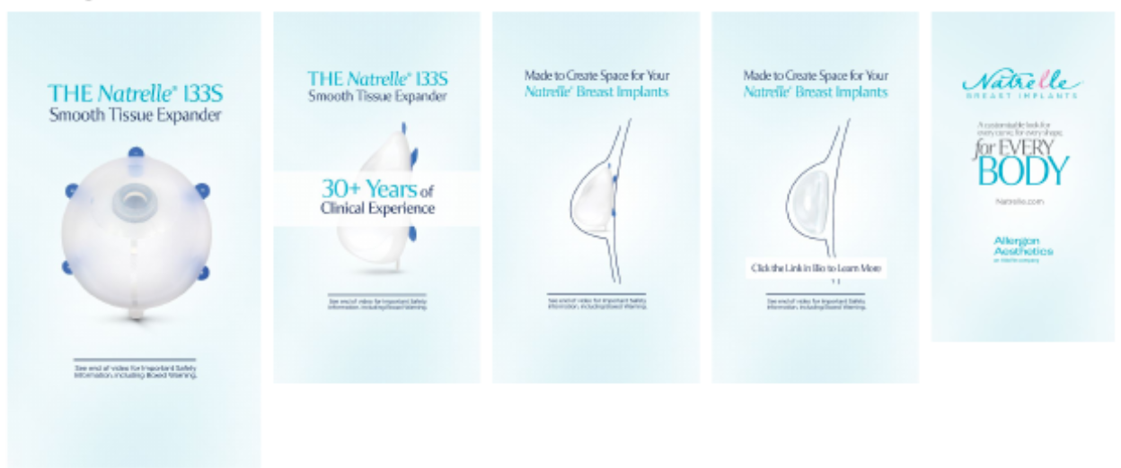

Post-Copy Caption

Natrelle® 133S Smooth Tissue Expanders are designed to help make your implant-based
breast reconstruction possible. Tissue expanders help create space for breast implants after a
mastectomy, and the Natrelle® 133S Smooth Tissue Expanders are made to fit your Natrelle®
breast implants.

To learn more about the Natrelle® 133S Smooth Tissue Expanders, contact our office for more information or schedule a consultation.

#myreconreason #askaplasticsurgeon #breastreconstruction #breastimplants #breastsurgery
#tissueexpander #implantbasedreconstruction #natrelletissueexpander #natrelleimplants #natrelleinspira #natrelle

Important Safety Information

For Facebook-Please add ISI copy to post copy.

