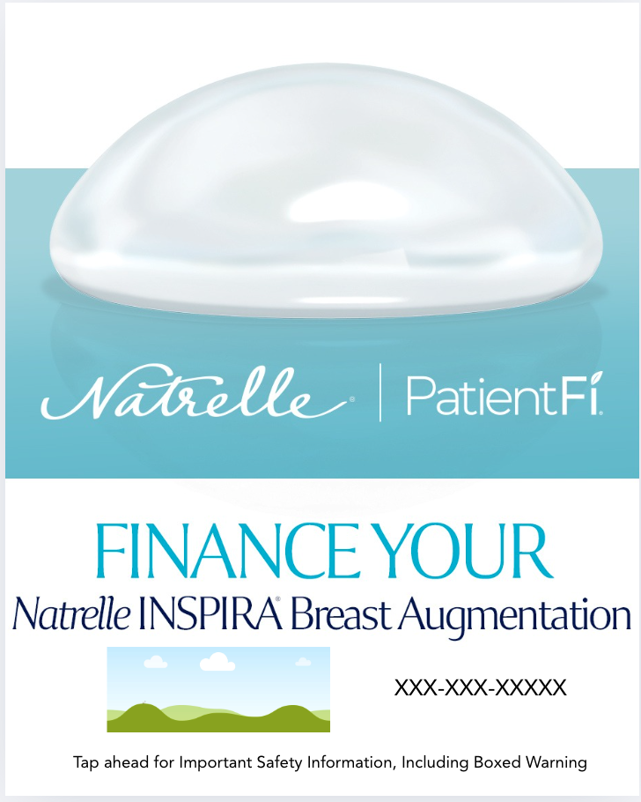

Patient Fi Customizable Canva Template

How To: Use these directions to download the editable Canva social media template.
Step 1: Click this link to view the template:
Step 2: If you have Canva, you can directly edit the file and move to step 3. If you do not, make Canva account with your email. It is free and takes 1 minute.
https://www.canva.com/design/DAGt80gHu9M/TaTC541QD9OWXYL6Hx09SA/view?utm_content=DAGt80gHu9M&utm_campaign=designshare&utm_medium=link&utm_source=publishsharelink&mode=preview
Step 3: Once in the platform, you can update the social template with your information by directly clicking the icon that looks like a “photo frame” and your phone number (XXX) XXX-XXXX In the photo frame icon, you can drag and drop your practice’s logo/your headshot (.png/.jpeg) from your computer.
Step 4: Add your practice’s phone number by clicking & deleting the (XXX) XXX-XXXX on the template
Note: Everything on the social template besides your logo/headshot + phone number are locked, so you cannot alter anything else on this image.
Step 5: Done! Click the “Download” icon 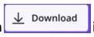in the upper right corner. Click on “file type” and scroll down and choose “PNG” to download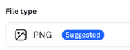 this full asset. Press “Download.”
Step 6: Your file is now downloaded to your computer & most likely in your “downloads” folder. Send the image(s) to yourself via Airdrop/email/or the method of your choice. Now, share it on social — upload it to IG/FB!
Approved Suggested Caption Copy:

IG/FACEBOOK POST COPY
You can get a customized financing plan for your new look with
PatientFi®, created for Natrelle INSPIRA® breast augmentation
patients. Get a payment plan that fits your budget with 0% interest*
plans available, flexible payment terms, and no hard credit checks. It's
financing, with you at the center.

Contact our office to learn more and apply for PatientFi® today.

*No interest if paid in full during the promotional period.

Important terms and conditions: All financing is subject to credit approval. Depending on
creditworthiness and choice of financing option, APRs range between 6.99% and 29.99%.
Scheduled payments are based on the full contract term length. Not every provider offers all product
term lengths and promotions. Please inquire which term lengths and promotions are available.
Allergan Aesthetics is not a financing company and is not responsible for and does not support the
financing referenced herein. All financing and support are provided by PatientFi. Patients and
healthcare providers should contact PatientFi with any questions. Patients should apply directly to
PatientFi for financing

