Channel: Instagram/Facebook
Title: Count on Natrelle

Multi-Image Post:

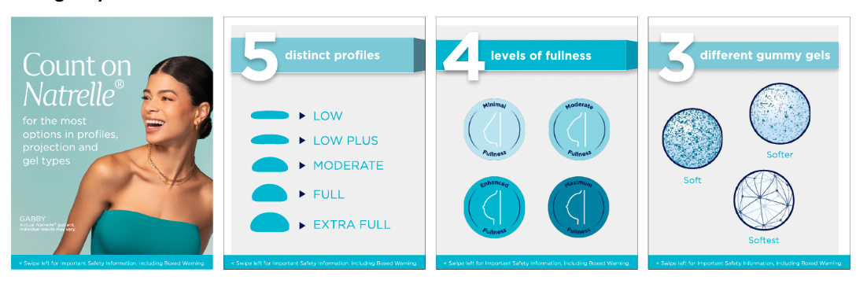

Post-Copy Caption

Count on Natrelle® to help achieve the look that's right for you. Natrelle® ensures a customized
look by being the ONLY breast implant brand to offer 5 implant projections, 4 fullness levels and 3
gummy gel levels. All in all, the Natrelle INSPIRA® collection has a total of 300 implants—the most
in the market—to choose from.
Contact our office for more information or schedule a consultation.

#natrelle #natrelleimplants #gogummy #breastimplants #breastaugmentation
#countonnatrelle #breastimplantchoices

Important Safety Information

For Instagram - Please add ISI frames as last image.
For Facebook-Please add ISI copy to post copy.

