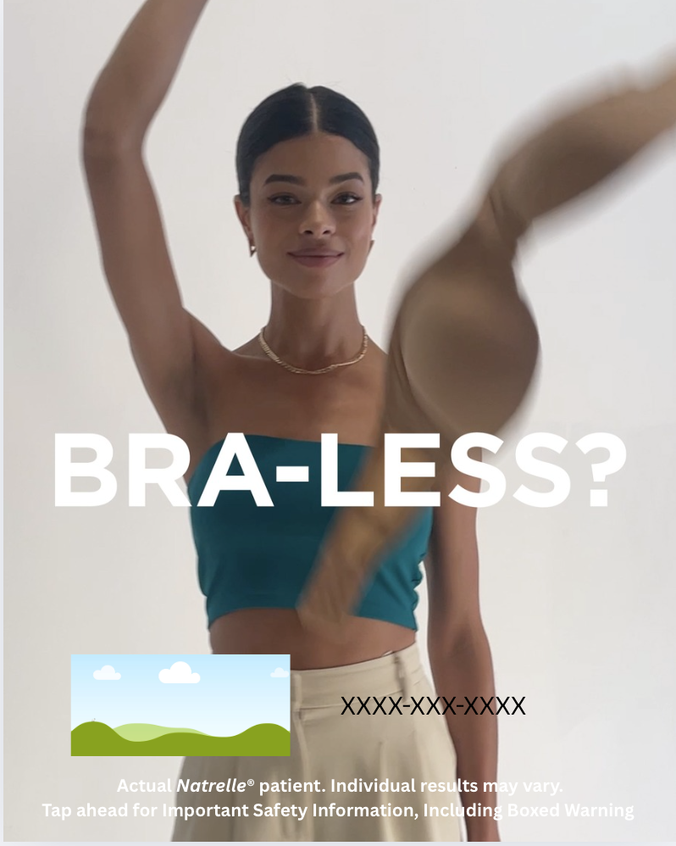

Natrelle® Bra Less Customizable Canva Template

How To: Use these directions to download the editable Canva social media template.
Step 1: Click this link to view the template:
Step 2: If you have Canva, you can directly edit the file and move to step 3. If you do not, make Canva account with your email. It is free and takes 1 minute.
https://www.canva.com/design/DAGt8bDdXmA/cqhVC9AdRhCSgZH1o686sQ/view?utm_content=DAGt8bDdXmA&utm_campaign=designshare&utm_medium=link&utm_source=publishsharelink&mode=preview
Step 3: Once in the platform, you can update the social template with your information by directly clicking the icon that looks like a “photo frame” and your phone number (XXX) XXX-XXXX In the photo frame icon, you can drag and drop your practice’s logo/your headshot (.png/.jpeg) from your computer.
Step 4: Add your practice’s phone number by clicking & deleting the (XXX) XXX-XXXX on the template
Note: Everything on the social template besides your logo/headshot + phone number are locked, so you cannot alter anything else on this image.
Step 5: Done! Click the “Download” icon 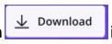in the upper right corner. Click on “file type” and scroll down and choose “PNG” to download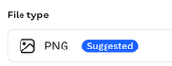 this full asset. Press “Download.”
Step 6: Your file is now downloaded to your computer & most likely in your “downloads” folder. Send the image(s) to yourself via Airdrop/email/or the method of your choice. Now, share it on social — upload it to IG/FB!
Approved Suggested Caption Copy:

IG/FACEBOOK POST COPY

If you could choose your own breasts, would you go bigger? Bolder? Bra-less? Proportional? Perky? Perfect for your body?

With more options than any other brand, the Natrelle INSPIRA® Breast Implant portfolio allows you and your surgeon to customize the look and feel you’ve been dreaming of.

Call us to book a consultation.

Intended for US audiences only.

#natrelle #natrelleimplants #gogummy #breastimplants #breastaugmentation #womensbreasthealth

