Channel: Instagram/Facebook
Title: Bra Free Beauty Reel

REEL:

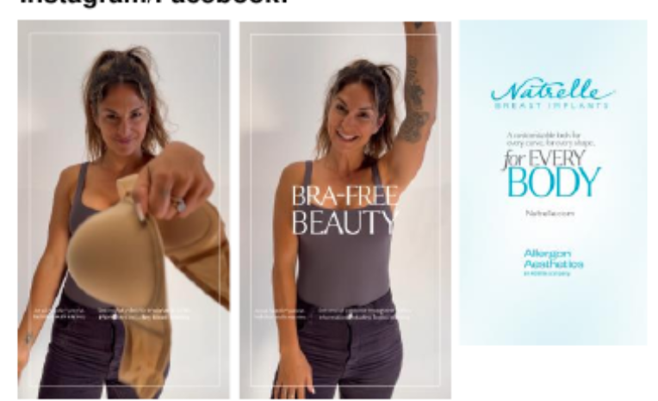

Post-Copy Caption

Say goodbye to your padded bras!

No more worrying about tight straps or pokey wires; it’s all you! With Natrelle INSPIRA® Breast
Implants, you can get a push-up look without underwire.

Ready to customize your look? Contact our office for more information or schedule a consultation.

#gogummy#askaplasticsurgeon#breastaugmentation#augmentation #gummyimplants
#plasticsurgery#gelimplants#breastimplants#ditchyourbra#newlook#nostrapsnowires
#permanentpushuplook#natrelleimplants#natrelleinspira#natrelle

Important Safety Information
For Facebook-Please add ISI copy to post copy.

