Channel: Instagram/Facebook
Title: A Perfect Match - Tissue Expander

STATIC

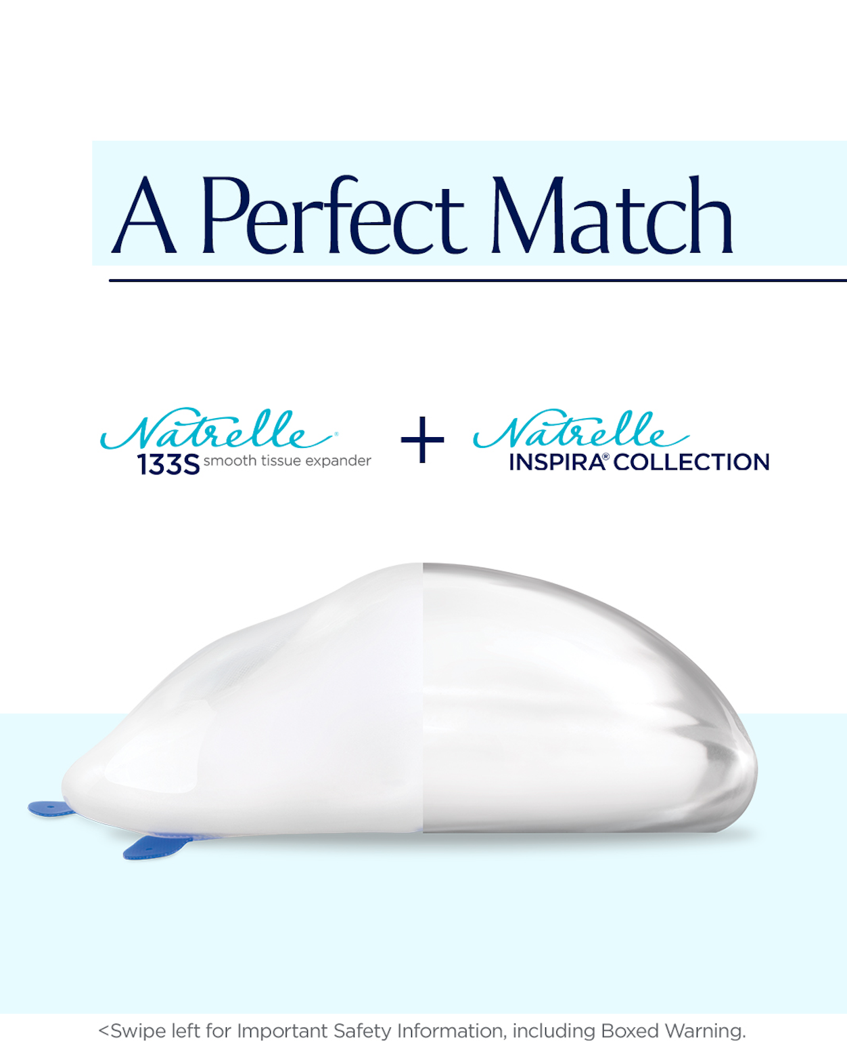

Post-Copy Caption

The perfect partners that are paired for precision.

Tissue expanders expand your breast pocket by inflating the tissue so your breast implants fit securely and comfortably. The Natrelle® 133S Smooth Tissue Expanders are designed with precision to perfectly match the Natrelle® breast implant collection.

To learn more about Natrelle® 133S Smooth Tissue Expanders and your breast reconstruction options, Contact our office for more information or schedule a consultation.

#myreconreason #askaplasticsurgeon #breastreconstruction #breastimplants #breastsurgery #tissueexpanders #natrelletissueexpanders #natrelleTE #natrelleimplants #natrelleinspira #natrelle

Important Safety Information

For Instagram - please add ISI frame as last images.
For Facebook-Please add ISI copy to post copy.

