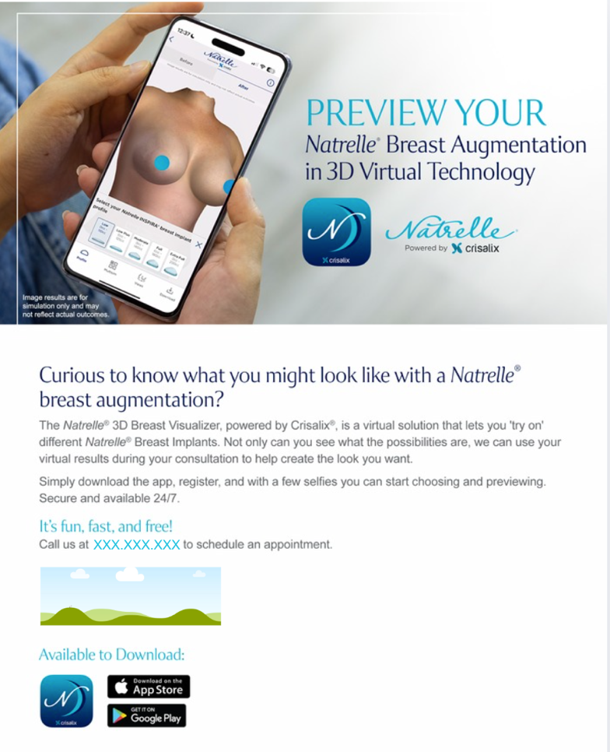

Natrelle® 3D Visualizer Customizable Canva EMAIL Template

How To: Use these directions to download the editable Canva social media template.
Step 1: Click this link to view the template:
Step 2: If you have Canva, you can directly edit the file and move to step 3. If you do not, make Canva account with your email. It is free and takes 1 minute.
https://www.canva.com/design/DAGvmH-h0l0/Xbu80mK8J3Fq6TOVGYI6ew/view?utm_content=DAGvmH-h0l0&utm_campaign=designshare&utm_medium=link&utm_source=publishsharelink&mode=preview
Step 3: Once in the platform, you can update the social template with your information by directly clicking the icon that looks like a “photo frame” and your phone number (XXX) XXX-XXXX In the photo frame icon, you can drag and drop your practice’s logo/your headshot (.png/.jpeg) from your computer.
Step 4: Add your practice’s phone number by clicking & deleting the (XXX) XXX-XXXX on the template
Note: Everything on the email template besides your logo/headshot + phone number are locked, so you cannot alter anything else on this image.
Step 5: Done! Click the “Download” icon 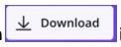in the upper right corner. Click on “file type” and scroll down and choose “PNG” to download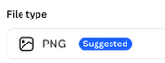 this full asset. Press “Download.”
Step 6: Your file is now downloaded to your computer & most likely in your “downloads” folder. Send the image(s) to yourself via Airdrop/email/or the method of your choice. Now, share it on social — upload it to IG/FB!
Approved Suggested Caption Copy:

IG/FACEBOOK POST COPY

Don’t let your new look be a surprise—just
visualize!

Start imagining your new look with Natrelle® 3D
Breast Visualizer, powered by Crisalix®. All you
need are some selfies and then you can start
choosing implant options to “try on.” How easy is
that??

Download the Natrelle 3D Breast Visualizer in the app store.

Contact our office and we can help you visualize your look with Natrelle breast implants.

