Channel: Instagram/Facebook STORY
Title: Smooth Tissue Expander

STORY

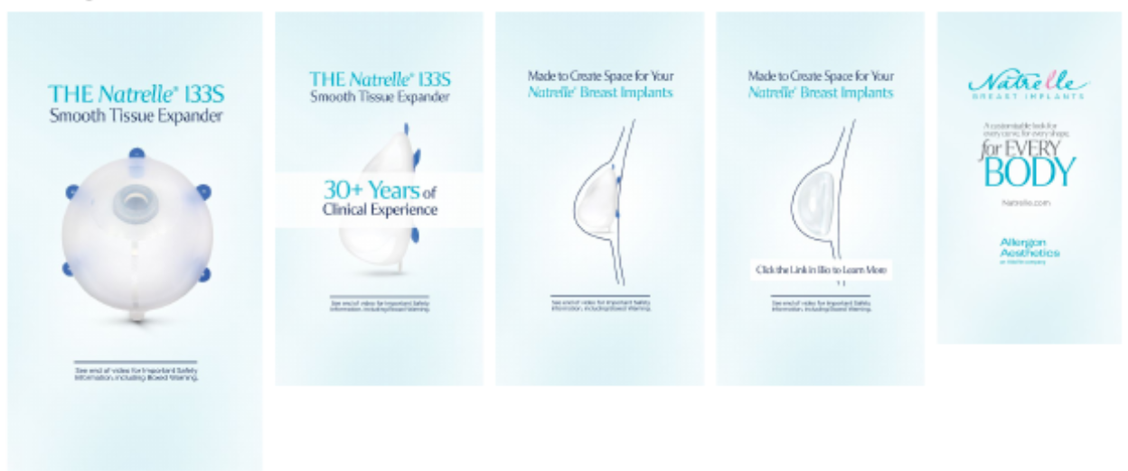

Important Safety Information

For Instagram & Facebook- Please add Tissue Expander ISI as frame 2.

