Channel: Instagram/Facebook
Title: Tissue Expander Match

REEL:

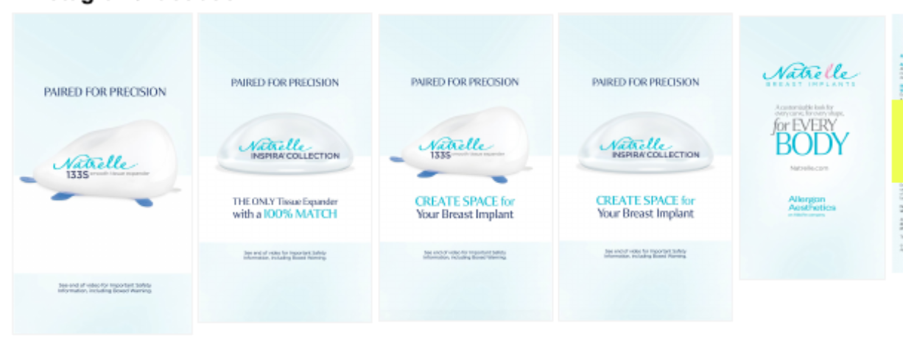

Post-Copy Caption

100% MATCH—The highest match rate for available tissue expanders.

The Natrelle® 133S Smooth Tissue Expanders allow your plastic surgeon to tailor the expanders to your specific needs to help create the results you want. The Natrelle® 133S Smooth Tissue Expanders offers a 100% match to each Natrelle INSPIRA® Breast Implant.* A 100% match means the tissue expander creates a breast pocket for your Natrelle® Breast Implants to fit.

Contact our office for more information or schedule a consultation.

*A precise match was defined as a breast implant that falls within a range of 0.5 cm smaller to 1.0 cm larger in base width and 1.5 cm smaller to 2.0 cm larger in projection of a tissue expander.

#myreconreason #askaplasticsurgeon #breastreconstruction #breastimplants #breastsurgery #TE
#natrelleTE #tissueexpander #natrelleimplants #natrelleinspira #natrelle

Important Safety Information
For Facebook-Please add ISI copy to post copy.

