CoolSculpting® HCP OOH Customizable Canva Template How To:
Please use the directions below to access and download the editable CoolSculpting® HCP OOH template(s) promoting your practice with an acquisition offer (i.e. $200 off) to eligible patients in 1920x1080 and 480x672 sizes.

- Step 1: Click the link to view the template of your preference:
  - Option 2
    - 1920x1080
    - 480x672

- Step 2: If you have Canva, you can directly edit the file and move to step 3. If you do not, make a Canva account with your email. It is free and takes 1 minute.
- Step 3: Once in the platform, you can update the social template with your information by directly clicking:
  - The icon that looks like a “headshot placeholder”

Note: In the photo frame icon, you can drag and drop your practice’s logo or your headshot (.png/.jpeg) from your computer.

Note: If a shows up on top of the information that you’d like to update, double click on the icon to unlock the content.
  - The text boxes
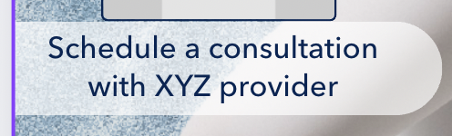
  - The QR Code
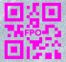
  - The Offer
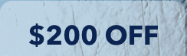
Note: The offer value is dependent on your preference
- Step 4: Add your practice’s phone number and address by clicking & deleting the XYZ provider, or 123 First St. on the template. If you are leveraging the $200 Off Acquisition template please generate a new QR code and add it into the template using the same instructions for replacing an image in step 3. The offer can also be customized to your desire.
Note: Everything on the social template besides your logo/headshot, phone number, and QR code are locked, so you cannot alter anything else on this image.
- Step 5: Done! Click the “Download” icon 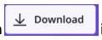in the upper right corner. Click on “file type” and scroll down and choose “JPG” to download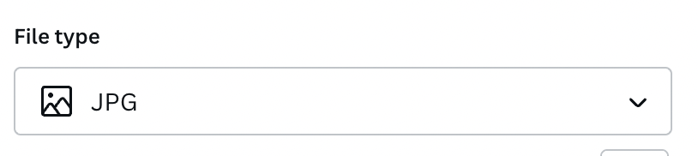. Press “Download.”
- Step 6: Your file is now downloaded to your computer & most likely in your “downloads” folder. Send the image to yourself via Airdrop/email/or the method of your choice.

