Allē “What’s in your Wallet” Flash Card Customizable Canva Template How To:
Use these directions to download the editable Canva social media template.
- Step 1: Click this link to view the template: Alle Flash Card
- Step 2: If you have Canva, you can directly edit the file and move to step 3. If you do not, make a Canva account with your email. It is free and takes just a moment.
- Step 3: Once in the platform, you can update the social template with your information by directly clicking and updating to your practice’s information.
- Step 4: Add your practice’s information by clicking on the template
  - Note: Everything on the social template besides your logo/headshot + phone number are locked, so you cannot alter anything else on this image.
- Step 5: Done! Click the “Download” icon 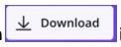in the upper right corner. Click on “file type” and scroll down and choose “MP4” to download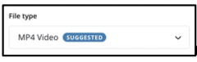 this asset as a full video. Press “Download.”
- Step 6: Your file is now downloaded to your computer & most likely in your “downloads” folder.

